

Department of Computer Science and Technology

Practical File
Design Thinking and Idea Lab

Course name : Design Thinking and Idea Lab Workshop
Course Code : HSMC-101
Submitted by : Irfan khan
Reg. No. : 24bthcse01
Submitted to : Dr. Anandika Sharma

Sr. No. | Experiment Name | Page No.
1. | Redesigning the library of University using design thinking approach | 3
2. | Enhancing the experience of people waiting in a hospital | 4
3. | Empathy map on University student problems Using Miro | 5
4. | Mind map on healthy lifestyle using Miro | 6
5. | Mind map on reducing plastic waste using Canva | 7
6. | Exploring Git, Github and VS code | 8-10
7. | Cloning a repository in github | 11-12
8. | Add ,commit and pushing a file in github | 13-14
9. | Working on Google Docs | 15
10. | Exploring Figma (Prototyping tool)
11. | Working with Tinkercad and introduction to Arduino
12. | PCB and PCB soldering
Index

Experiment no. 1
# Redesigning the library of University using design thinking
Steps:-
1) Empathize :- (Conduct user surveys and interviews to understand student and faculty needs. Here the users are the students of the university.)
Several problems that are faced by the students seems to be :-
- Students waste too much time in finding books.
- Seats are uncomfortable for sitting.
- Books are in irregular manner.
- Need of adjustable ladder near book shelf .
- Need to increase time of Library.
- Loss of time in attendance .
- Bad smell in air .

2) Define :-( Identify key challenges and opportunites for improvement )
Important key points to consider :
- Students have issues in finding books .
- There is not enough space for housing in reading rooms.
- Students complaint about uncomfortable seats and less space also.
- If a book is issued by some student, then there is no other way to get it.
- Loss of time in attendance.

3) Ideate:-(Here we mention some ideas to solve the problem)
- For finding books : A digital application or web store which can tell us about the location of the book (i.e. shelf no. etc) can be used .
- An already existing self checkout station should be upgraded to let us know about the book whether it is issued or not.
- An adjustable height feature should be there for the bookshelf or a step ladder should be provided on each floor .
- Helpers should be there to find the books on higher shelves .
- Modern seating can be introduced to accommodate even more people within the same space with increased comfortabiltiy .

4). Prototype :-(Here we mention how to apply the idea)
- An ID checking system of some sort should be used in reading rooms .While entering the reading room , the student will check-in using their ID so that no. of students in the reading room and no. of available seats can be displayed on the web application.
- A web application should be used to know the location of books .
- The round chairs and circular tables should be arranged in circular formats.
Experiment no. 2
#Enhancing the experience of people waiting in a hospital

Steps

1).Empathize :- (Conduct interviews with patients , family members and hospital staff)
Several problems that are faced by people seems to be :
- Long waiting times.
- Environment is Uncomfortable for people .
- Emotional distress(e.g., fear ,worry etc).
- Uncertainety and anxiety.
- Physical discomfort (seating, temperature etc).
- Limited amenities(e.g. food ,water etc).
- Parking and accessibility issues .

2). Define :- (Identify key challenges and opportunities for improvement )
Important points to consider :
- People have to wait for long times.
- People feel stressed and worried .
- Discomfort in interacting to others.
- Limited amenities (e.g. food, water etc).
- People have to face difficulties in parking their vehicles.

3). Ideate :- ( Here we mention some ideas to solve the problems)
- Digital wait-time tracking system can be used for tracking the wait-time updates.
- Comfortable seating designs.
- On-site beverage options should be used .
- Games should be there for entertainment purpose to reduce stress and anxiety.
- Trained staff to assist with parking.
- AI Sensors should be used to detect available spots for parking.

4). Prototype :- (Here we mention how to apply the idea)
- Interactive wait-time display.
- Adjustable seating chairs with built-in charging ports.
- Gaming system for entertainment .
- AI sensor for detecting available spots for parking .
Experiment no. 3
#Working with Miro

A 3rd year University student is facing problems like time management, part time jobs and maintaining strong CGPA. Make an Empathy map for the user ‘s needs
Miro is an online collaborative whiteboard platform designed to help teams and individuals work together, brainstorm, plan, and create visually. It's commonly used for various purposes like project management, ideation, wireframing, and design thinking.
We will use Miro tool to make an empathy map :

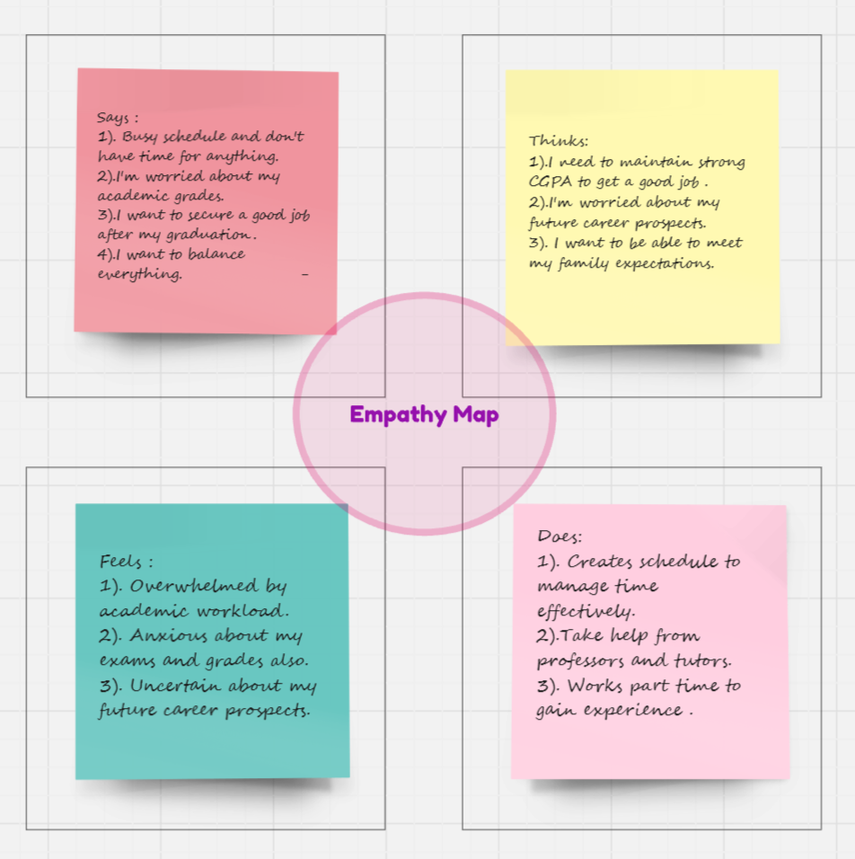

Experiment no. 4
# Mind Map on Healthy Lifestyle

Miro tool is also used for designing mind maps. We wil make a mind map on helath lifestyle using Miro.

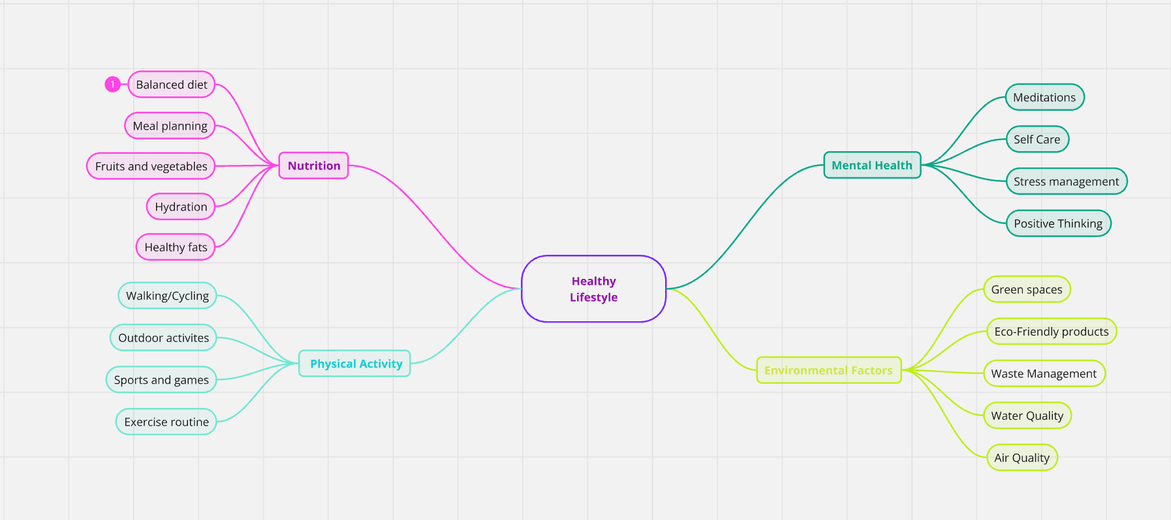

Experiment no. 5
# Working With Canva

Canva is an easy-to-use, web-based graphic design tool that allows users to create a wide variety of designs without needing advanced design skills. It's especially popular for creating social media graphics, presentations, posters, flyers, and more. Here, we will use Canva tool for designing a mind map on reducing plastic waste.

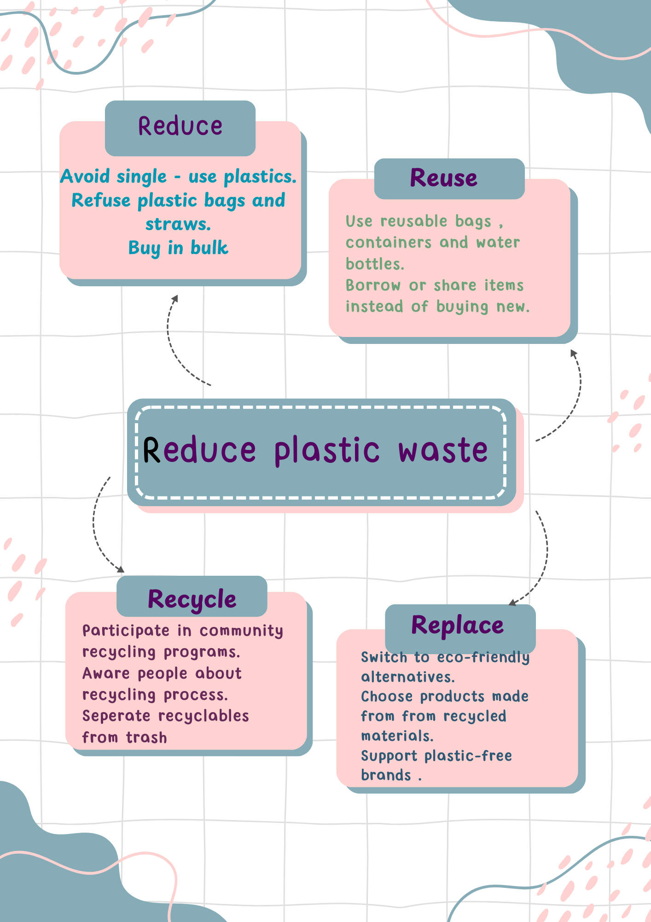

Experiment no. 6
# Exploring Git , Github and Visual studio Code

Exploring the Github :
Github is a web based application that is used for creating projects. It allows developers to manage their code, repositories , track changes , and collaborate with others through features like pull requests, cloning repositories.

1. Open a web browser.
2. Search for Github.
3.Open the website.
4.Click on signup and create your account.
5. Sign in to your account.
6.Click on new option to create new repository. Enter repository name ,select that you want to make your repository public or private.
7.Select the option of readme file according to your need .
8.Click on create repository.

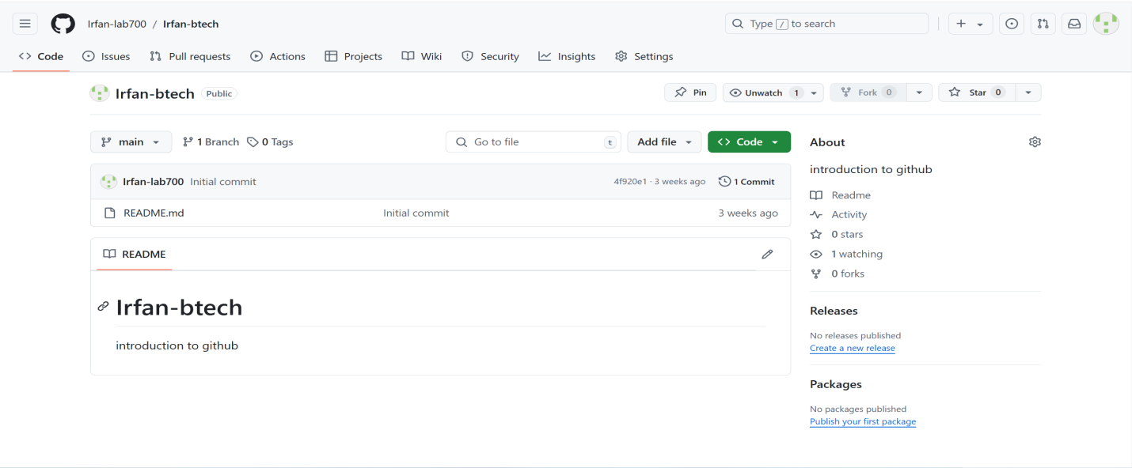

Exploring the Gitbash :

Gitbash is a tool commonly used by developers working with Git. It gives the access to the full functionality of Github on their local environment.

1. Install Git by a web browser.
2.Open the Gitbash.
3. Write the following commands to configure the git .
(i). git config -– global user.name”name”
(ii). git config -– global emai.id “email”
(iii). git config –list

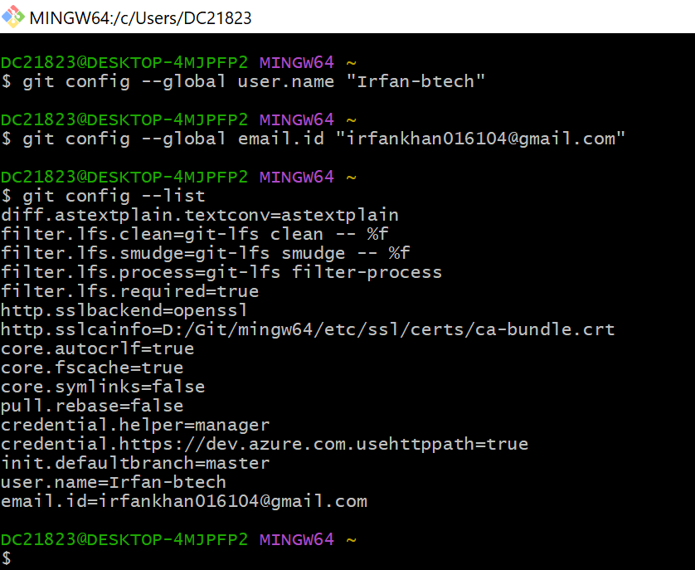

Exploring the visual studio code :

Visual studio code (VS code) is a lightweight, open source code editor developed by Microsoft. It is used by developers across various programming languages due to its high speed and versatility.

1. Download the VS code extension file by using a web browser.
2.Install the VS code.
3.Open VS code.
4. To access your directory present on git hub:
(i). On the menu bar, click on three dots.
(ii). Some other options appear on screen.
(iii). Click on terminal.
(iv)In the terminal, write the syntax git clone <repository link>
5. For repository in git hub ,click on code and copy the link.

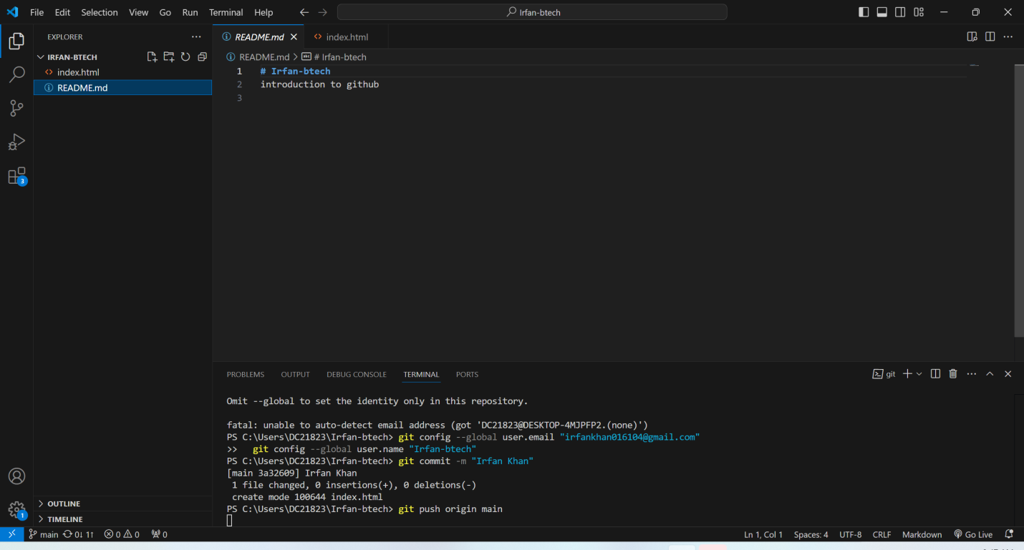

Experiment no. 7
#Cloning a repository in Github.

To clone a repository in Github, we have to use following commands in gitbash :
1. git config -–global user.name”name”
2. git config -–global email.id “email”
3. git config – list

After using these commands in gitbash open visual studio code and use the following steps :
(i). (i). On the menu bar, click on three dots.
(ii). Some other options appear on screen.
(iii). Click on terminal.
(iv)In the terminal, write the syntax git clone <repository link>

Experiment no. 8
#To add, commit and push a file to github from VS code

To add a new file in VS code, here are the steps, :
1. Open the VS code.
2.Click on file option and then click on new file option.
3.create your file name ,(i.e, index.html).
4. The new file will be created on VS code.
5.Open the terminal and write command “git add index.html”.
6. To check the status write command “git status “.

To commit and push the file to github:

1. Write anything in the new created file.
2.On the terminal write the command “git command-m” any message that you have entered in your file.
3.And then use the command “git add”.
4. To push the file on the terminal write the command “git push origin main”.

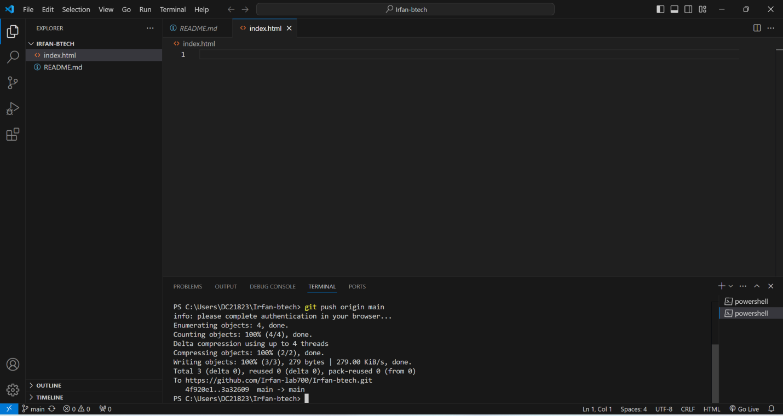

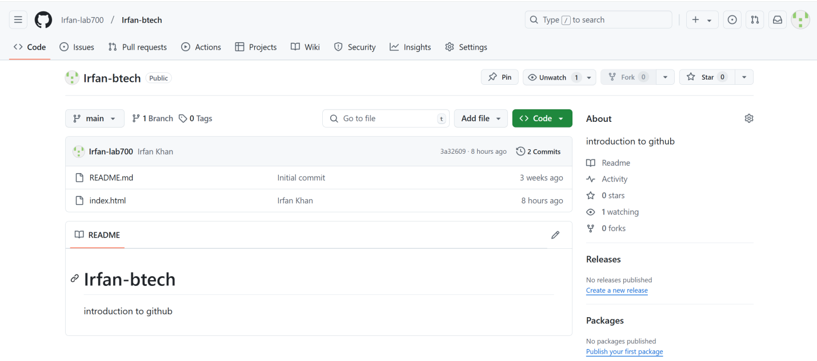

Experiment no. 9
# Working with Google Docs

Q-1). Identify and explain the phases of product engineering design process. Illustrate each phase with an example of a product , describing the challenges faced and how they were solved.

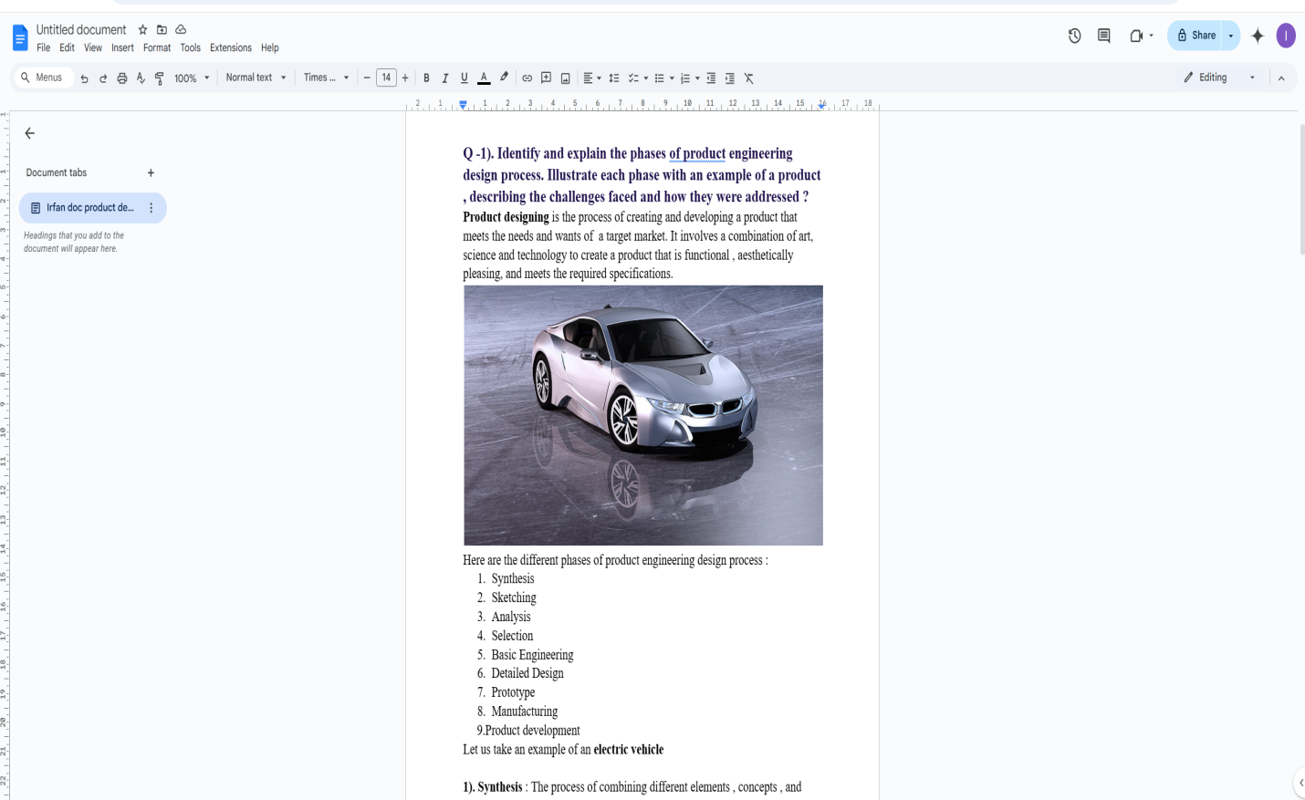

Experiment no. 10
#Exploring Figma ( Prototyping tool )

Figma:

Figma is an essential guide for creating user interfaces (UI), prototypes, and collaborative designs . It is a cloud-based design tool used for UI/UX design, prototyping, and collaboration.
Key features include:

1).Real-time collaboration: Multiple users can work on the same design simultaneously.
2).Cloud storage: Work is saved online automatically.
3).Cross-platform access: Use Figma on Windows, macOS, or even in a web browser.
4).Free: It is free to use.

Setting up Figma :

1).Create an Account:
2).Go to figma.com and sign up for a free account.
3).Install the Desktop App (Optional)

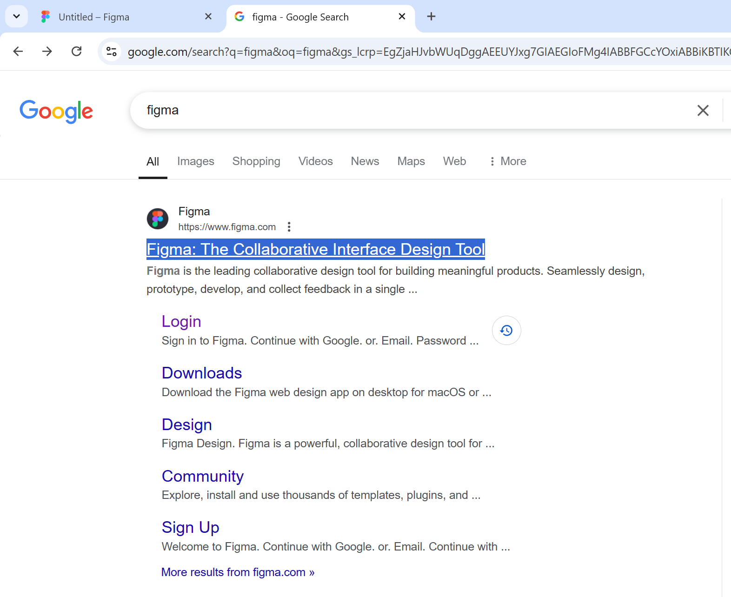

Steps in Figma :

1).Create a New File:
2).From the dashboard, click “+ New File.”
3).Add a Frame:
4).Use the Frame Tool (F) to create a frame. Presets are available for devices (desktop, phone, tablet).
5). Design according to your wish.
(i) You can add different types of frames.
(ii) You can Design any app easily with this free tool .

Here , you can see how to start designing with the figma tool.

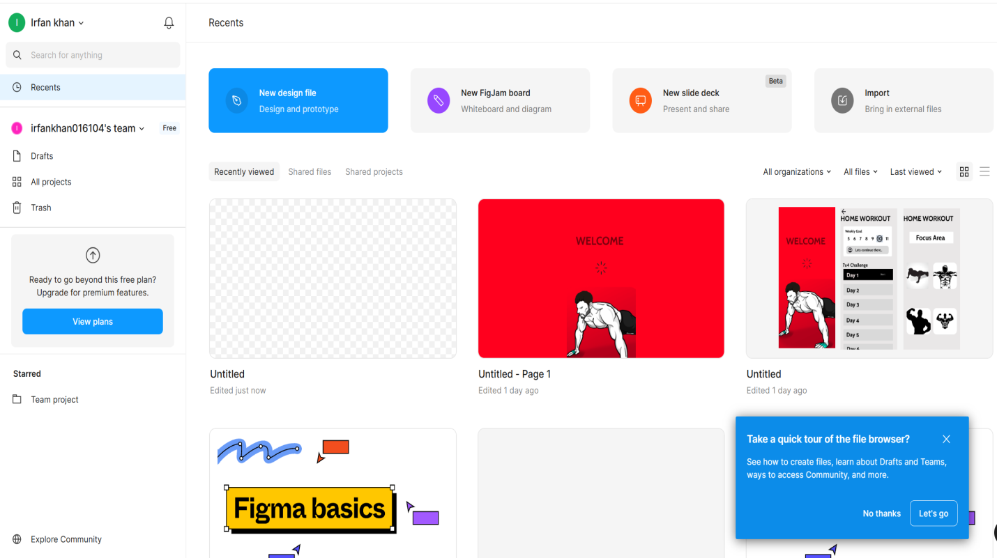

Here, We have designed a Home workout app using Figma tool :
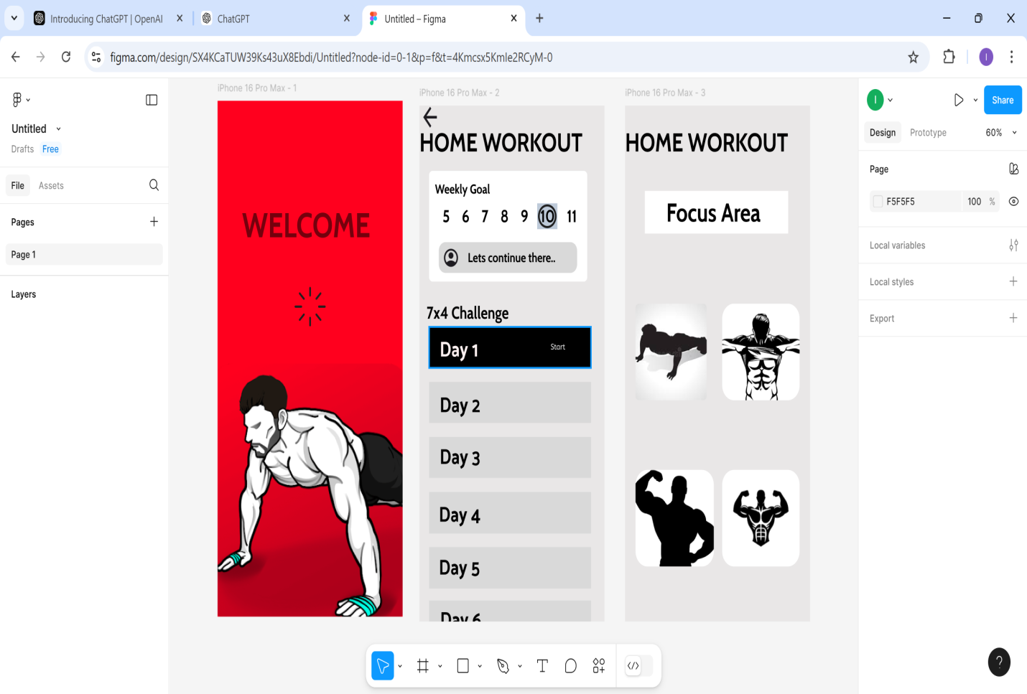


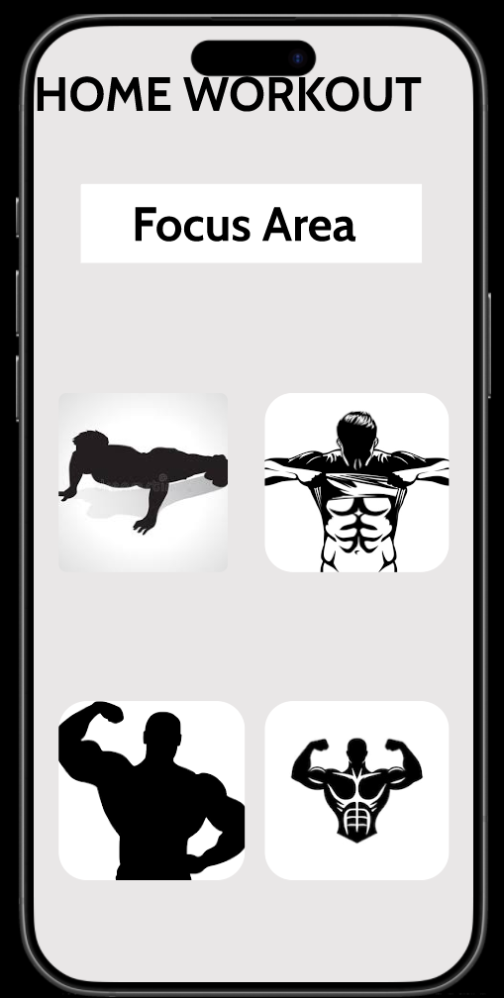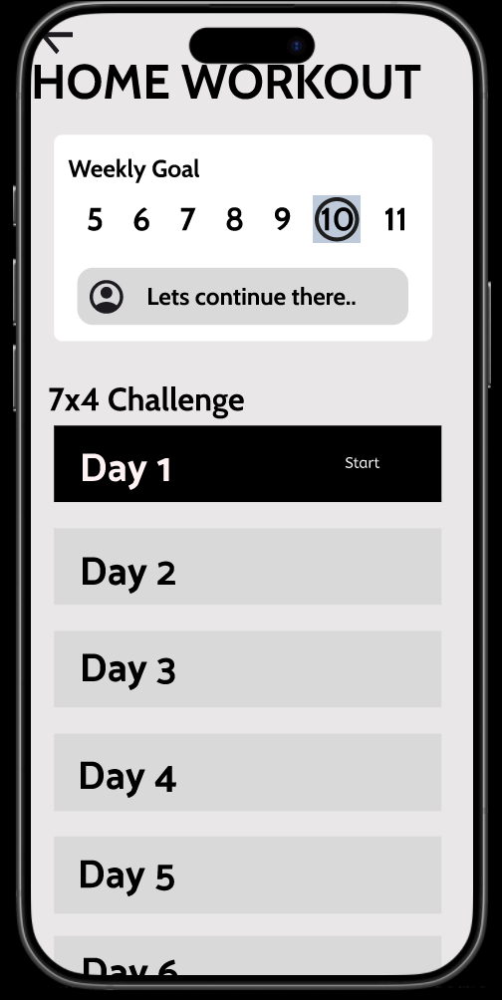

Experiment no. 11
#Working with Tinkercad and Introduction to Arduino

Tinkercad is a great platform for beginners to get started with 3D design, electronics, and Arduino programming. It provides a simple and intuitive environment for designing circuits, simulating Arduino code, and even creating 3D models. Here's a basic guide on how you can start working with Tinkercad and Arduino:
Introduction to Arduino : Arduino is an open-source electronics platform based on easy-to-use hardware and software. It is widely used for building digital devices and interactive objects that can sense and control the physical world.
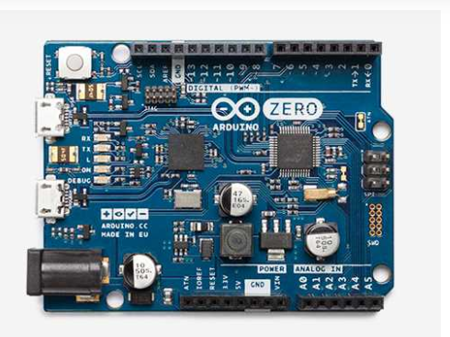

1. Getting Started with Tinkercad
- Sign Up/Log In: Visit Tinkercad and create an account or log in.
- Create a New Project: Once logged in, you can choose from different projects. Select "Circuits" to start working on Arduino projects.
- You can add components like an Arduino board, LEDs, resistors, motors, sensors, and more, simply by dragging them from the right panel into the workspace.

2. Working with Arduino in Tinkercad
- Select the Arduino Board: From the components menu, search for "Arduino" and drag the "Arduino Uno" into the workspace.
- Adding Components: You can add components like:
  - LEDs (to display output)
  - Resistors (to protect components)
  - Buttons/Sensors (for input)
  - Motors/Servos (for controlling movement)
- Connect Components: Use the wiring tool to connect the components on the breadboard. For example, connect an LED to pin 13 and a resistor to ground.

3. Writing Arduino Code
- Code Editor: Click on the "Code" button to open the code editor. Tinkercad allows you to write Arduino code in C/C++ syntax.
- Basic Example – Blink LED:
- Simulate the Code: After writing your code, press the "Start Simulation" button. The virtual Arduino will execute the code, and you should see the LED blink.
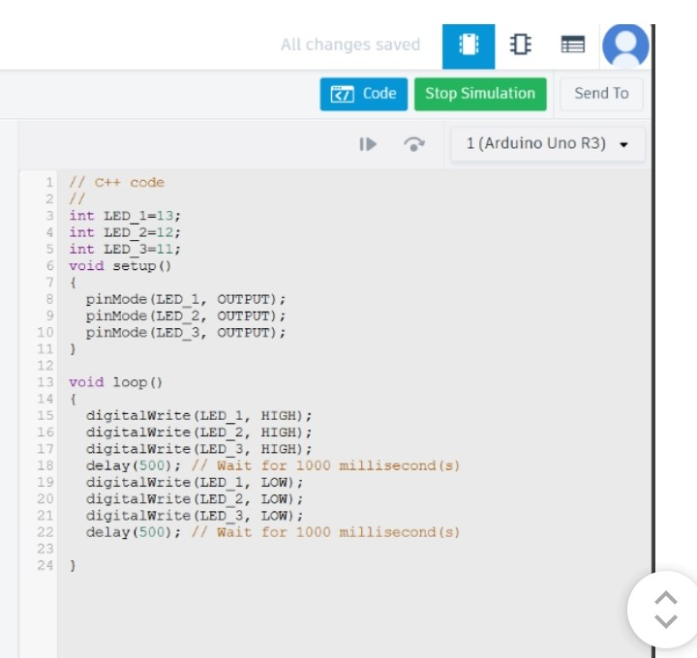
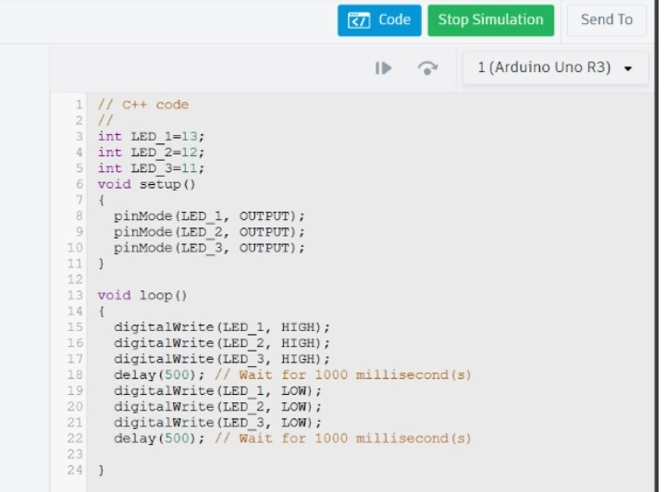
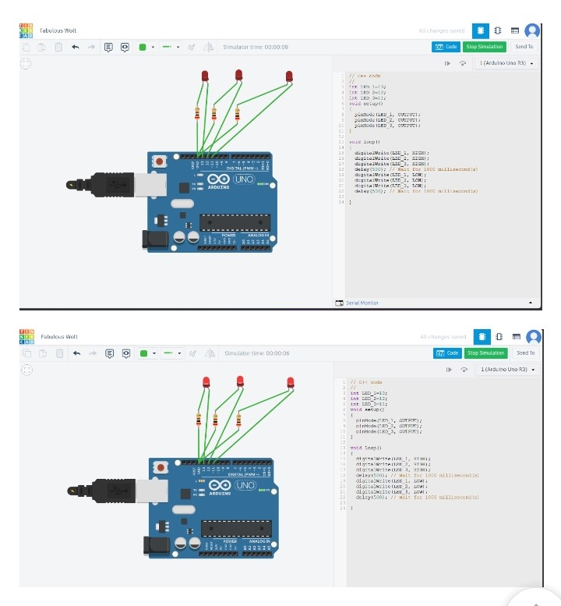

Experiment no. 12
#PCB
A PCB (Printed Circuit Board) is a flat board made of insulating material, typically fiberglass or plastic, with conductive pathways etched or printed onto it. These conductive pathways, usually made of copper, allow electrical components to connect and interact with each other in electronic devices.

